**Semantic HTML**

**Problem 1. Refactoring**

* Refactor (edit) the [homework-refactoring.html](https://github.com/TelerikAcademy/HTML/blob/master/6.%20Semantic%20HTML/homework-refactoring.html) web page and make it HTML semantic.

**Problem 2. Student System**

* Create a web page using semantic HTML by the design.
* Use some kind of approach to support old (non-HTML5-compatible) Web browsers like IE8.

[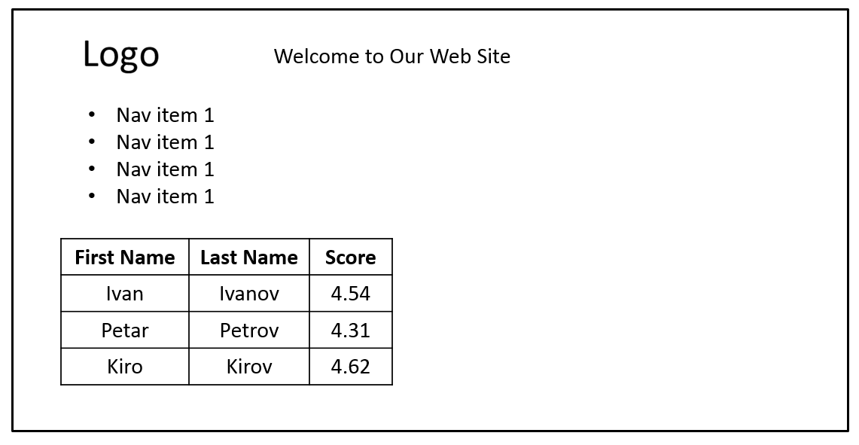](https://cloud.githubusercontent.com/assets/3619393/7179645/ba6f880e-e442-11e4-9f54-235e88cb686a.png)

*Note: Do not try to make the same styles. Implement just the content with its semantics.*

**Problem 3. LinkedIn**

* Create a web page using semantic HTML by the design.

[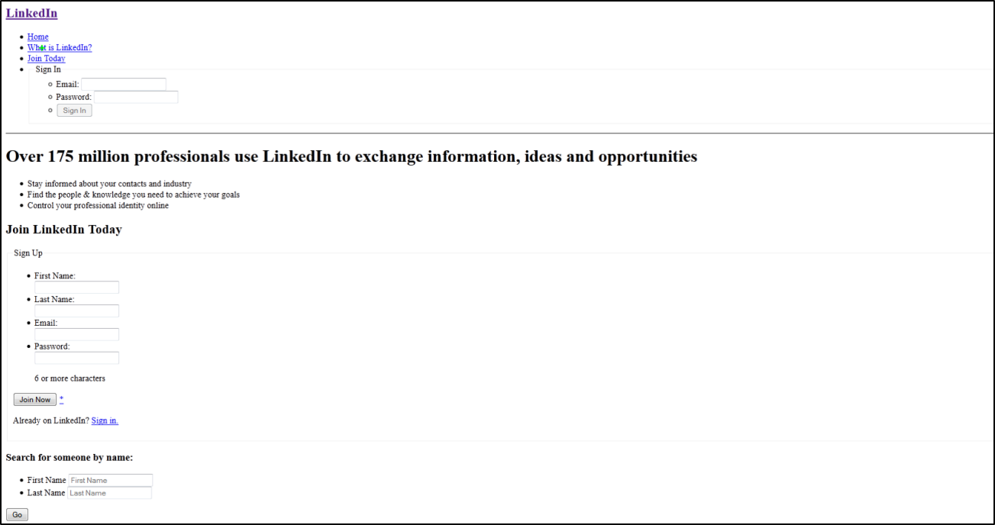](https://cloud.githubusercontent.com/assets/3619393/7179271/ac996bf4-e43e-11e4-981f-d0914a8ca92d.png)

*Note: Do not try to make the same styles. Implement just the content with its semantics.*